
TECHNICAL UNIVERSITY OF KENYA
FACULTY OF APPLIED SCIENCES AND TECHNOLOGY
SCHOOL OF COMPUTING AND INFORMATION TECHNOLOGY
END OF SEMESTER EXAMINATION SERIES
FIRST SEMESTER EXAMINATION SERIES 2019/2020
FOURTH YEAR EXAMINATION FOR THE DEGREE OF:
BACHELOR OF TECHNOLOGY INFORMATION TECHNOLOGY
BACHELOR OF TECHNOLOGY COMPUTER COMMUNICATION NETWORKS
ECII 4102/ECCI 4102: MULTIMEDIA SYSTEMS
Time: 2 Hours

Instructions to candidates:
This paper consists of FIVE Questions.
Answer Question ONE [30 Marks] and any other TWO Questions [20 Marks Each]
Write your college number and questions attempted on the answer sheet.
This paper consists of 4 printed pages

Candidates should check the question paper to ascertain that all the pages are printed as indicated and that no questions are missing

© The Technical University of Kenya Examination Series
QUESTION 1 (30 MARKS) COMPULSORY
- Define the term multimedia [2 Marks]
Multimedia refers to the integration of various types of media such as text, graphics, audio, video, and animation, into a single presentation or application. Multimedia combines different forms of communication to provide a richer and more engaging experience for the user.
- Ted Nelson invented the term “hypermedia” around 1965. Using two relevant examples discuss the connection between Multimedia and its root in
Hypermedia within the context of its historical backgrounds [4 Marks]
- Hypertext is an early form of hypermedia that was developed in the 1960s as a way to organize and connect textual information. It allows the user to navigate through a series of interconnected documents by following hyperlinks embedded within the text. This concept was further developed in the 1980s with the creation of HyperCard, a software program that allowed users to create their own hypermedia presentations by linking together text, graphics, and audio. HyperCard was one of the earliest multimedia authoring tools, and it played a significant role in the development of multimedia applications.
- The World Wide Web is another example of hypermedia that has had a profound impact on the development of multimedia. The Web was created in the late 1980s as a way to share and distribute information over the Internet. It uses hypertext to link together documents, images, audio, and video, and it allows users to navigate through this information using a web browser. The Web has become the primary platform for multimedia applications, and it has enabled the creation of a wide range of multimedia content, including websites, online videos, and interactive applications.

- Do you agree or disagree with the following statement: “multimedia is simply a collection of different types of media” Explain your answer in detail [2 Marks]
I disagree, multimedia is more than just a collection of different types of media. It involves the integration of these elements in a way that creates a cohesive and engaging experience for the user, and it relies on technology to enable interactivity and customization.
- You have been asked to transmit the smell of a rose flower over the internet. The aroma will be transmitted over the internet and reproduced at the receiver’s location. List two key issues and one main consideration that justifies why this task can be classified as multimedia task [3 marks]
- Two key issues related to transmitting the smell of a rose flower over the internet are the technology required and the ability to reproduce the scent accurately. The technology to capture and transmit the scent of a rose flower does not currently exist, and it would require significant research and development to create such a technology. Additionally, even if the technology existed, it would be challenging to reproduce the scent accurately at the receiver's location, as factors such as air temperature, humidity, and air pressure can affect the way a scent is perceived.
- One main consideration that justifies why this task can be classified as a multimedia task is the integration of different types of media. In this case, transmitting the scent of a rose flower would involve the integration of scent, which is a type of sensory information, with other types of media such as visual and auditory information. This integration of different types of media to create a cohesive and immersive experience for the user is a defining characteristic of multimedia. By transmitting the scent of a rose flower along with visual and auditory information, the user can experience a more complete and engaging multimedia experience.

- State any four applications of multimedia [4 marks]
- Entertainment: One of the most popular applications of multimedia is in the entertainment industry. Movies, TV shows, video games, and music all rely on multimedia to create engaging and immersive experiences for the audience.
- Education and Training: Multimedia is also widely used in education and training to enhance the learning experience. Multimedia applications can provide interactive simulations, virtual tours, and other engaging content to help students understand complex concepts.
- Advertising and Marketing: Multimedia is often used in advertising and marketing to promote products or services. Online ads, TV commercials, and social media campaigns often use multimedia elements such as video, graphics, and sound to capture the viewer's attention.
- Healthcare: Multimedia is also used in healthcare to educate patients about various medical conditions and treatments. Multimedia applications can provide detailed visualizations of the human body, interactive tutorials on medical procedures, and other resources to help patients better understand their health.

f) Define data compression and describe how data is compressed in Multimedia [4 marks]
Data compression is the process of reducing the size of digital data files without significantly affecting the quality of the information they contain. In multimedia, data compression is used to reduce the size of media files such as images, audio, and video, making them easier to store, transfer, and stream over the internet.
There are two types of data compression techniques: lossless and lossy compression.
- Lossless compression: This type of compression technique reduces the size of a file without losing any data. In lossless compression, the original data can be completely reconstructed from the compressed data. Examples of lossless compression algorithms include ZIP, RAR, and PNG.
- Lossy compression: This type of compression technique reduces the size of a file by removing data that is less important or less noticeable to the human eye or ear. In lossy compression, the compressed data cannot be completely reconstructed to its original form. Examples of lossy compression algorithms include JPEG, MP3, and MPEG.
In multimedia, data compression is used to reduce the size of media files to make them easier to store, transfer, and stream. For example, when a video is recorded, it generates a large amount of data, which makes it difficult to transfer or store the file. By using a lossy compression algorithm like MPEG, the video can be compressed to a much smaller size while maintaining an acceptable level of quality. Similarly, when an image is captured, it generates a large amount of data, which makes it difficult to store or transfer. By using a lossless compression algorithm like PNG, the image can be compressed to a smaller size without losing any data.

g) Use a diagram to draw an illustration of the two main parts of the architecture of generic framework of cloud gaming [3 marks]
- Front-end or client-side: This part of the architecture is responsible for handling user inputs and rendering the game graphics on the user's device. The front-end or client-side typically consists of a thin client, such as a web browser or a mobile app, that communicates with the back-end or server-side.
- Back-end or server-side: This part of the architecture is responsible for handling the game logic and processing the user inputs. The back-end or server-side typically consists of a powerful server that runs the game and streams the video and audio output to the user's device. The server-side may also include components such as load balancers, game engines, and content delivery networks to optimize the gaming experience.

h) List four characteristics of multimedia application systems [4 marks]
- Integration of multiple media types: Multimedia application systems are designed to handle multiple media types, such as text, images, audio, video, and interactive elements, and to present them to users in a seamless and integrated manner.
- Interactive and engaging: Multimedia application systems are often designed to be interactive and engaging, allowing users to interact with the content and control the presentation of the media.
- Large file sizes: Multimedia application systems often require large file sizes due to the inclusion of multiple media types, which can make them more challenging to store, transfer, and stream compared to other types of applications.
- High processing requirements: Multimedia application systems often require high processing requirements due to the complexity of the media and the need for real-time processing and rendering of the media. This can be a challenge for devices with limited processing power, such as mobile devices and low-end computers.

i) Correctly define the following terminologies as used in Multimedia:
i) McGurk effect
ii) MIDI [4 marks]
i) McGurk effect: The McGurk effect is a perceptual phenomenon that occurs when the visual information of a speaker's mouth movements conflicts with the auditory information of the spoken sounds. The brain perceives a different sound than what is actually being heard due to the influence of the visual cues of the mouth movements. The McGurk effect is commonly used in multimedia research to study the effects of audio-visual integration on perception.
ii) MIDI: MIDI stands for Musical Instrument Digital Interface, which is a protocol used in the communication between electronic musical instruments, computers, and other devices. MIDI messages are used to control various aspects of musical performance, such as note on/off, pitch, volume, and control changes. MIDI is commonly used in multimedia applications for music production, sound design, and interactive music performance. MIDI files can be used to store musical performances and can be edited and played back on different devices.

QUESTION TWO (20 Marks)
a) Define Entropy encoding [2 Marks]
Entropy encoding is a data compression technique that is used to reduce the amount of data required to represent a piece of information. It works by assigning shorter codes to frequently occurring symbols or values and longer codes to less frequently occurring symbols or values. This is based on the concept of entropy, which is a measure of the randomness or uncertainty of a given set of data.
b) Use the information in the table below to calculate the file size in kilobytes of a 16-bit depth colour image with a resolution of 1024 by 768 pixels? [3 marks]
Bit depth | Number of colours or tones | relationship
1 | 2 | 2¹ = 2
2 | 4 | 2² = 4
3 | 8 | 2³ = 8
4 | 16 | 2⁴ = 16
6 | 64 | 2⁶ = 64
8 | 256 | 2⁸ = 256
16 | 65,536 | 2¹⁶ = 65, 536
24 | 16,777, 216, | 2²⁴= 16, 777, 216
32 | 4,294,967,296 | 2³²= 4, 294,967, 296
File size = horizontal x vertical x bit depth / 8 x 1024 bits
To calculate the file size of the image, we need to know the total number of pixels in the image and the size of each pixel.
The image has a resolution of 1024 by 768 pixels, which means there are a total of 1024 x 768 = 786,432 pixels in the image.
The image has a color depth of 16 bits, which means each pixel can be represented by 2 bytes (16 bits / 8 bits per byte).
Therefore, the total size of the image in bytes is:
786,432 pixels x 2 bytes per pixel = 1,572,864 bytes
To convert bytes to kilobytes, we divide by 1024:
1,572,864 bytes / 1024 = 1,536 kilobytes (rounded to the nearest kilobyte)
Therefore, the file size of the 16-bit depth color image with a resolution of 1024 by 768 pixels is approximately 1,536 kilobytes.

- Name two types of extra information which make spoken text is better at conveying compared to written text [2 marks]
- Tone and inflection: Spoken text can convey tone and inflection, which can add nuance and emotion to the message being conveyed. This can help to better convey the speaker's intended meaning and can add emphasis or context to certain words or phrases.
- Nonverbal cues: Spoken text can also convey nonverbal cues, such as facial expressions, gestures, and body language, which can provide additional context and meaning to the message being conveyed. This can help to better convey the speaker's intent and can add clarity or emphasis to certain aspects of the message.

d) Differentiate between the two commonly used multimedia signals shown in the diagram below. List two considerations you would need to take into account before converting an analog audio signal into digital. [4 marks]
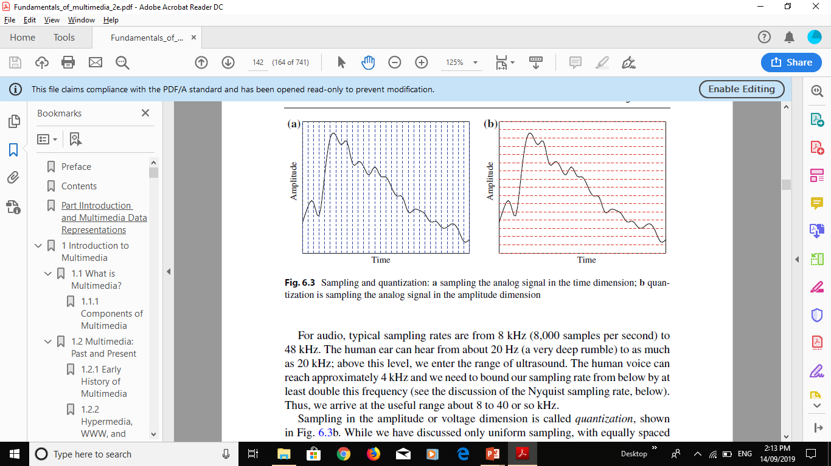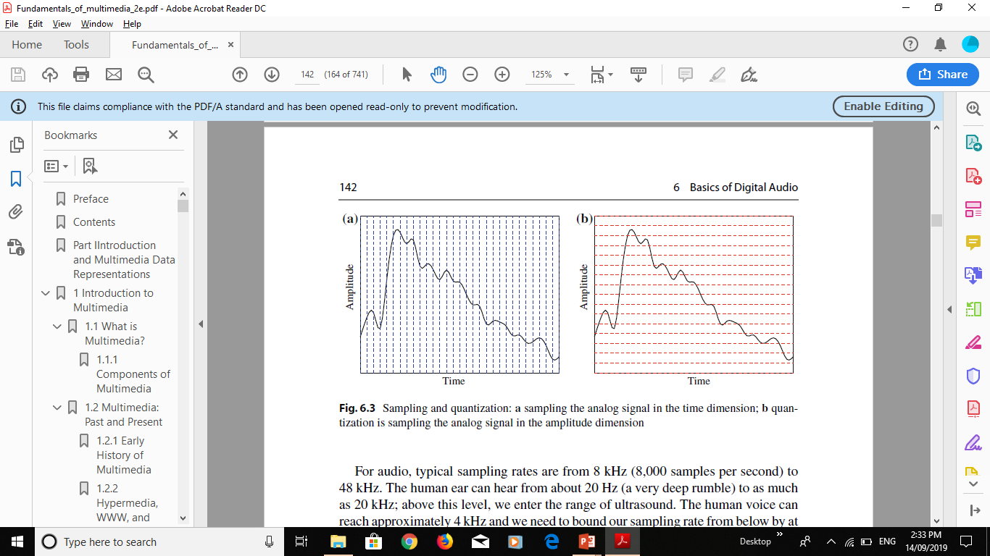

- Analog Signal: An analog signal is a continuous signal that varies in amplitude or frequency over time. Analog signals are often used for sound and video signals and can be transmitted over a range of frequencies.
- Digital Signal: A digital signal is a discrete signal that consists of binary data represented as a series of 0s and 1s. Digital signals are commonly used in multimedia applications and can be transmitted over long distances without loss of quality.
Considerations before converting an analog audio signal into digital:
- Sampling Rate: The sampling rate is the frequency at which the analog audio signal is sampled and converted into a digital signal. The sampling rate determines the accuracy of the digital signal and affects the quality of the resulting sound. A higher sampling rate results in better sound quality but also requires more storage space.
- Bit Depth: The bit depth refers to the number of bits used to represent each sample of the analog audio signal. A higher bit depth results in better dynamic range and sound quality but also requires more storage space.
Before converting an analog audio signal into digital, two considerations that need to be taken into account are the quality of the analog audio signal and the intended use of the digital audio signal. The quality of the analog audio signal can affect the resulting digital audio quality, so it is important to ensure that the analog audio signal is of high quality. Additionally, the intended use of the digital audio signal should be considered, as this can impact the required sampling rate and bit depth for the digital audio signal.

- The ratio of picture width to height can be 4:3, 16:9, 1.8.5.1 or 2.0.1 used in video display. Which one does high definition TV (HDTV) use, and why it is preferred over the others? [3 marks]
  - High-definition TV (HDTV) uses a ratio of 16:9 for its display. This ratio is also commonly known as widescreen format.
  - The 16:9 aspect ratio is preferred over other ratios because it closely matches the human field of view, providing a more immersive viewing experience. Additionally, it allows for a wider viewing angle, making it easier for multiple viewers to watch a program from different positions without losing image quality.

f) State 3 benefits of using the cloud for gaming? [3 marks]
- Accessibility: Cloud gaming allows gamers to access games from any device with an internet connection, without the need for specialized gaming hardware. This means that gamers can play their favorite games on a wider range of devices, including smartphones, tablets, and laptops, without having to worry about the limitations of their hardware.
- Cost-effectiveness: Cloud gaming can be a cost-effective alternative to traditional gaming, as it eliminates the need for expensive gaming consoles and hardware upgrades. Gamers can simply subscribe to a cloud gaming service and stream games to their devices, paying only for the games they want to play.
- Scalability: Cloud gaming services can easily scale to meet demand, as they can dynamically allocate resources based on the number of players and the complexity of the game. This means that gamers can enjoy high-quality gaming experiences without experiencing lag or latency, even during peak usage periods. Additionally, cloud gaming services can easily add new games and features, providing gamers with a wide range of choices and experiences.

g) You have been asked to diagnose a computer to determine what caused it to stop functioning. Explain three key steps you would undertake [3 marks]
- Collect information and perform a preliminary assessment: Before diagnosing the problem, I would first collect as much information as possible from the user about what happened before the computer stopped functioning. This might include any error messages that were displayed, any recent changes made to the computer's hardware or software, and any symptoms that the user has noticed. I would also perform a preliminary assessment of the computer's physical components, including checking for loose cables or connections, and checking for any visible signs of damage or wear and tear.
- Perform diagnostic tests: Once I have collected enough information about the problem, I would perform diagnostic tests to narrow down the possible causes of the issue. This might include running system diagnostic tests to check for any hardware failures or errors, running virus and malware scans to check for any malicious software that might be causing the issue, and checking system logs for any error messages or warnings that might provide clues about the problem.
- Identify the root cause and recommend a solution: After performing diagnostic tests, I would analyze the results to identify the root cause of the problem. Based on my analysis, I would recommend a solution to the user, which might involve repairing or replacing hardware components, updating software drivers or operating system patches, or removing viruses and malware. I would also provide the user with instructions for implementing the solution and offer any additional advice or support they might need.

QUESTION THREE (20 MARKS)
a) Explain the Nyquist Sampling theorem [2 marks]
The Nyquist Sampling Theorem is a fundamental principle in signal processing and digital signal theory that states that in order to accurately reconstruct a continuous signal from its sampled values, the sampling rate must be at least twice the highest frequency component in the signal.
b) You wish to produce a graphic/video/presentation that is pleasing and easily readable. Suppose the background colour is pink, what multimedia colour test would you use to find out which different colour text font you could use to make the text most readable? Explain your answer
[2 Marks]
To find the most readable text font color to use on a pink background, a designer can conduct a multimedia color test known as the contrast ratio test. The contrast ratio test measures the relative luminance between the foreground text color and the background color to ensure that the text is easily readable and accessible to all users, including those with visual impairments.
To conduct the contrast ratio test, a designer can use a color contrast calculator, which is widely available online. The calculator requires the designer to input the RGB or HEX values of both the background color (in this case, pink) and the text color, and it will output the contrast ratio between the two colors.
The contrast ratio is expressed as a numerical value between 1:1 and 21:1, with higher values indicating better contrast between the text and background. According to the Web Content Accessibility Guidelines (WCAG), the minimum recommended contrast ratio for normal text is 4.5:1, while larger text (18pt or 14pt bold) should have a minimum contrast ratio of 3:1.
Therefore, by using a contrast ratio calculator, a designer can experiment with different text colors and find the most readable and accessible option for their pink background. They can adjust the text color until they achieve a contrast ratio that meets or exceeds the WCAG recommendations. This ensures that their graphic, video, or presentation is easily readable and accessible to all users, regardless of any visual impairments they may have.

c) Name three different ways in which video signals can be organised [3 marks]
- Interlaced: Interlaced video is a method of displaying video in which each frame is divided into two fields, with odd and even lines of the image displayed separately. The fields are displayed one after the other in quick succession, creating the illusion of a full image. Interlaced video was commonly used in older analog TV systems and is still used in some digital broadcasting systems.
- Progressive: Progressive video is a method of displaying video in which each frame is displayed in its entirety, with all lines of the image displayed at the same time. This creates a smoother, more natural-looking image than interlaced video, with less flicker and fewer artifacts. Progressive video is commonly used in digital video formats, including DVDs and Blu-ray discs, as well as in digital broadcasting.
- High Dynamic Range (HDR): HDR is a newer video format that allows for a wider range of brightness and color than traditional video formats. HDR video can display more detail in bright and dark areas of the image, creating a more lifelike and immersive viewing experience. HDR video requires special equipment to display, including HDR-compatible TVs and monitors.

d) What is the difference between NTSC video, PAL video and SECAM video standards?
[3 marks]
- NTSC: NTSC (National Television System Committee) is a broadcasting standard used mainly in North America, parts of South America, and some Asian countries. It has a frame rate of 30 frames per second (fps) and a resolution of 525 lines per frame. NTSC uses a 3.58 MHz color subcarrier frequency and a 4.5 MHz sound carrier frequency.
- PAL: PAL (Phase Alternating Line) is a broadcasting standard used mainly in Europe, Australia, and parts of Asia and Africa. It has a frame rate of 25 fps and a resolution of 625 lines per frame. PAL uses a 4.43 MHz color subcarrier frequency and a 5.5 MHz sound carrier frequency. PAL has better color reproduction than NTSC, with a higher color resolution and less color bleeding.
- SECAM: SECAM (Sequential Color with Memory) is a broadcasting standard used mainly in France, Russia, and parts of Africa and Asia. It has a frame rate of 25 fps and a resolution of 625 lines per frame, the same as PAL. However, SECAM uses a different method for encoding color information than PAL and NTSC, which means that SECAM broadcasts are not compatible with NTSC or PAL televisions. SECAM has better color reproduction than NTSC but not as good as PAL.

e) Using the information in the table below calculate the file size in MB of a CD quality audio that uses a sample rate of 44.1kHz with a 16 bit sample size and a track that lasts for 3 minutes in stereo? [4 marks]
Sampling rate | Best uses | File size = sample rate x sample size x time (in seconds) x channels
11 kHz | Recommended for speech and short segments of music
22 kHz | Better music playback
32 kHz | Broadcast audio standard
44 kHz | CD quality audio playback
48 kHz | Digital audio tape (DAT) playback
Given: Sampling rate = 44.1 kHz Sample size = 16 bits Duration of track = 3 minutes = 180 seconds Channels = stereo = 2
Using the formula provided in the table:
File size = sample rate x sample size x time (in seconds) x channels File size = 44.1 kHz x 16 bits x 180 seconds x 2 channels File size = 1411200 bits
To convert bits to MB: 1 byte = 8 bits 1 kilobyte (KB) = 1024 bytes 1 megabyte (MB) = 1024 KB
File size in MB = 1411200 bits / (8 bits/byte x 1024 KB/byte x 1024 MB/KB) File size in MB = 5.37 MB (approx.)
Therefore, the file size of a CD quality audio that uses a sample rate of 44.1kHz with a 16 bit sample size and a track that lasts for 3 minutes in stereo is approximately 5.37 MB.

- Why do different styles of games have different thresholds for maximum tolerable delay? [2 marks]
Different styles of games have different thresholds for maximum tolerable delay because they require different levels of real-time responsiveness to provide an optimal user experience.
For example, games that require fast reflexes, such as first-person shooter games or racing games, demand a low latency connection to ensure that the game responds quickly and accurately to the player's actions. In these games, any delay between the player's input and the game's response can significantly impact the gameplay experience and may cause frustration for the player.
On the other hand, turn-based strategy games or puzzle games may have a higher latency threshold since the gameplay is not as time-sensitive, and the players have more time to think and make decisions.
Therefore, different styles of games have different maximum tolerable delay thresholds based on their gameplay mechanics and the required level of real-time responsiveness needed to provide an optimal user experience.

g) You run a diagnostic program on your PC and it reports that your memory and video card are worn out. Describe two multimedia tests you would need to run to resolve this problem? [4 marks]

If a diagnostic program reports that the memory and video card of a PC are worn out, two multimedia tests that can be run to resolve the problem are:
- Memory Test: A memory test is necessary to check the functionality of the memory modules. This test can help determine if the memory modules need replacement. There are several memory test programs available that can be used to scan the memory for errors. One example of a memory test program is Memtest86, which can be run from a bootable USB or CD.
- Video Card Test: A video card test can help determine if the video card is working correctly. A video card stress test can be run to check if the video card is capable of handling heavy multimedia applications such as games and video editing. One example of a video card stress test program is FurMark, which can stress-test the video card and provide a benchmark score to compare with other video cards.
Running both the memory test and video card test can help diagnose the problem and determine if the components need replacement. If the tests reveal that the memory and video card are faulty, then they need to be replaced to restore the system to optimal performance.

QUESTION FOUR (20 MARKS)
a) Define the following terminologies as used in multimedia
i) Cocktail effect
ii) Sound
iii) Text [3 marks]
i) Cocktail effect: This is a phenomenon where a person focuses on one sound source in a noisy environment and filters out other sounds. It is also known as the "the party effect" or "the cherry-picking effect" because a person can pick out a particular sound, like a voice, in a noisy environment like a party.
ii) Sound: Sound refers to the vibration of air particles that create waves that travel through the air and are detected by the ear. In multimedia, sound can be used to enhance the user's experience, such as background music, sound effects, and voice-overs.
iii) Text: In multimedia, text refers to written words that can be used to convey information or messages. Text can be used in various multimedia formats such as subtitles in videos, captions in images, and headings in presentations. Text can also be used as a standalone medium, such as e-books and online articles.

b) Name the most salient differences between ordinary TV and HDTV. What was the main impetus for the development of HDTV? [4 marks]
- Picture quality: HDTV provides a much higher resolution picture quality than ordinary TV. HDTV has a minimum resolution of 720p, which is much higher than the 480p resolution of ordinary TV.
- Aspect ratio: HDTV has a widescreen aspect ratio of 16:9, while ordinary TV has a standard aspect ratio of 4:3.
- Sound quality: HDTV provides high-quality digital sound, while ordinary TV typically provides only analog sound.
- Transmission: HDTV uses a digital signal for transmission, while ordinary TV uses an analog signal.
The main impetus for the development of HDTV was the desire to provide viewers with a more immersive and realistic viewing experience. HDTV provides a much higher resolution picture quality, which makes it possible to see more detail and depth in the images. The widescreen aspect ratio of HDTV also makes it possible to see more of the picture and creates a more immersive viewing experience. Additionally, the development of digital technology made it possible to transmit HDTV signals, which provided a much higher quality of sound and picture than was possible with analog signals.

c) Minimum hardware requirements for running games is dual core CPU over 2.4 Ghz, with 2 GB RAM, 20GB storage, and 512 RAM graphics card. Discuss two implications this has for smartphones and tablets? [4 marks]
- Processor Speed: The minimum requirement for the processor speed is 2.4 GHz. This is a high requirement for a smartphone or tablet because it could lead to higher power consumption and heat generation. To compensate for this, the processor has to be optimized to ensure it does not overheat or drain the battery too quickly. This could mean that the overall performance of the device may be compromised if it is not adequately optimized.
- Storage Space: The minimum storage space required for running games is 20GB. This is a significant amount of storage space for a smartphone or tablet, especially considering that some devices have a maximum storage capacity of 128GB or less. This could mean that users may have to delete other apps or files to create enough storage space to install and run games. Additionally, this could also lead to users having to purchase a device with a higher storage capacity, which could be more expensive.

d) Name the two picture expert groups that set standard for file compression formats, and list three multimedia types which they have developed standards for [4 marks]
The two picture expert groups that set standards for file compression formats are:
- MPEG (Moving Picture Experts Group): They have developed standards for multimedia types such as video compression, audio compression, and digital television broadcasting.
- JPEG (Joint Photographic Experts Group): They have developed standards for still image compression.

e) State the type of equipment that should be used to extinguish a computer hardware fire and list three reasons why it is recommended [4 marks]
A class C fire extinguisher should be used to extinguish a computer hardware fire.
Three reasons why it is recommended are:
- Safety: A class C fire extinguisher is specifically designed to extinguish fires caused by electrical equipment. Using a different type of fire extinguisher may cause electric shock or harm to the person trying to put out the fire.
- Effectiveness: A class C fire extinguisher contains a non-conductive extinguishing agent that effectively puts out electrical fires without causing further damage to the equipment.
- Protection: Using the correct type of fire extinguisher can help prevent the spread of the fire and minimize damage to the surrounding area.

f) In your own words describe what is CHKDSK and explain what it does [1 marks]
CHKDSK is a command-line utility tool that is used to check the file system and disk surface of a hard drive. Its primary function is to detect and repair errors on the file system and file metadata, such as the Master Boot Record (MBR) and partition table. CHKDSK can also detect and mark bad sectors on the disk surface, preventing the operating system from writing to those areas and causing further data loss. CHKDSK is a useful tool for maintaining the health and integrity of a hard drive, and can help prevent data loss caused by disk errors.

QUESTION FIVE (20 MARKS)
a) State any two categories of computer games [2 marks]
- Casual Games: These are games that are easy to learn and can be played in short sessions. They often have simple mechanics and are designed to be played by a wide audience, including non-gamers. Examples include puzzle games, arcade games, and mobile games.
- Hardcore Games: These are games that are more complex and require more time and skill to play. They often have intricate mechanics, deep storylines, and high levels of challenge. They are typically targeted at experienced gamers and enthusiasts. Examples include first-person shooters, role-playing games, and strategy games.

b) Write the word MULTIMEDIA in ASCII computing text language [2 marks]
In ASCII computing text language, "MULTIMEDIA" would be represented as:
77 85 76 84 73 77 69 68 73 65

c) “Web browsers come with all of the necessary plugins for playing multimedia content” discuss in sufficient detail whether the above statement is true or false [3 marks]
The statement that "Web browsers come with all of the necessary plugins for playing multimedia content" is mostly false.
While modern web browsers do come with many built-in multimedia capabilities such as support for HTML5 audio and video, WebGL graphics, and even some basic image editing tools, there are many types of multimedia content that require additional plugins or software to work properly.
For example, some older websites may use Adobe Flash, which requires a separate plugin to be installed in the browser. Similarly, some websites may use specialized video codecs that are not natively supported by the browser, such as the HEVC/H.265 codec. In these cases, users may need to install additional plugins or software to properly view or interact with the multimedia content.
Furthermore, even if a web browser does come with built-in support for a particular multimedia format, it may not necessarily be able to play back the content smoothly or at high quality on all devices. For example, older computers or mobile devices with slower processors may struggle to play back high-resolution video content.
In summary, while modern web browsers do come with many built-in multimedia capabilities, there are still many cases where additional plugins or software may be required to properly view or interact with multimedia content on the web.

d) Define the following term as used in multimedia
i) App store
ii) Hardware resource conflict
iii) Augmented reality [6 marks]
i) App store: An app store is a digital platform where users can search, download, and install software applications or mobile apps that are compatible with their devices.
ii) Hardware resource conflict: A hardware resource conflict occurs when two or more hardware devices connected to a computer try to use the same system resources, such as input/output ports or memory, at the same time. This can lead to errors, system crashes, or other problems.
iii) Augmented reality: Augmented reality (AR) refers to a technology that enhances a user's real-world environment by overlaying digital information, such as text, graphics, or sound, onto it in real-time. AR can be experienced through mobile devices or special AR headsets.

e) Explain the following terms as used in multimedia: -
i) Static data
ii) Temporal relationships
iii) Computer animation
i) Static data refers to data or information in multimedia that is fixed and does not change or move. Examples of static data in multimedia include images, graphics, and text.
ii) Temporal relationships in multimedia refer to the relationship between different media elements or objects in terms of time. This includes the timing and sequencing of different elements, such as the synchronization of audio and video or the timing of transitions between different visual effects.
iii) Computer animation refers to the process of creating moving images using computer graphics. It involves the use of software tools and techniques to generate images that simulate motion, either in 2D or 3D. Computer animation is commonly used in various multimedia applications, including video games, films, advertising, and education. It allows for the creation of realistic and visually engaging content that can convey complex ideas and concepts.

[6 marks]
f) In a graphical user interface (GUI) system. Which folder & icon would you go to in order to change the screen resolution? [1 mark]
In a graphical user interface (GUI) system, you would typically go to the "Display settings" folder to change the screen resolution. The folder may be located in different places depending on the operating system and version, but it is usually found within the system settings or control panel. The icon for the display settings folder may vary as well, but it often looks like a computer screen or a display monitor.

